
National University of Sciences & Technology (NUST) Balochistan Campus (NBC), Department of Computer Science
Department of Computing
CS-250: Data Structure and Algorithms
Class: BSCS Fall 2022
Lab 3: Use knowledge of linked lists to implement a small functionality
Date: 2nd October 2024
Time: 10:00- 13:00
Lab Engr: Safder Ali

NAME | SAMEER TALREJA
CMS | 457795

CS250: Data Structures and Algorithms Page 1

National University of Sciences & Technology (NUST) Balochistan Campus (NBC), Department of Computer Science
Lab 3: Use knowledge of linked lists to implement a small functionality
Introduction
Doubly circular linked lists are important data structures which are used in many applications. Students have learned the fundamental concepts of circular linked lists in the lectures. This lab will introduce students with the practical implementation of a doubly circular linked list and different operations that can be performed on it.
Objectives
Objective of this lab is to familiarize students with the doubly circular linked list and implement them in C++.
Tools/Software Requirement
Visual Studio C++
Helping Material
Lecture slides. Text book.
Description
This lab is about the implementation of the doubly linked list and circular linked list. In doubly linked list you have two pointers in the link part of node i.e. next and previous pointers. With the help of these pointers it becomes very easy to transverse the list. In circular linked list the successor of tail pointer points to the head pointer or start of the linked list. And every new node is added after the last node but before the first node. Keeping these concepts in mind, solve the lab tasks.
CS250: Data Structures and Algorithms Page 2

National University of Sciences & Technology (NUST) Balochistan Campus (NBC), Department of Computer Science
The basic operation consist of
• Creating the list.
• Inserting nodes at the beginning, at the end and at a a specific location. • Deletion nodes at a specific location.
• Traversing/displaying the data in the list.
Lab Tasks
Use the partially written C++ code to implement a doubly circular linked list. The following are the important features (to be implemented):
1. Create a doubly circular linked list.
2. Create a function which can insert data at the beginning of the list.
3. Create a function which can insert data at the end of the list.
4. Create a function which can insert data at any location within the list. 5. Create a function which can delete a node at a specific location.
6. Create a function that can display the contents of the linked list.
Important Note: Practice your knowledge of OOP with C++ when creating a solution. Partial Code:
/* C++ Program to Implement Circular Doubly Linked List
*/
#include<iostream>
#include<cstdio>
#include<cstdlib>
using namespace std;
/*
* Class Declaration
*/
class DoubleCircularList

{
public:
int counter = 0;
/*
* Node Declaration
*/
struct node{
int info;
struct node *next;
struct node *prev;
}*start, *last;
DoubleCircularList(){
start = NULL;
last = NULL;
}
/*
*CREATE NODE AND ALLOCATE MEMORY DYNAMICALLY
*/
node* createNode(int value){
struct node *temp;
//your code here
cout << "+++++++++++++ You have to write code for createNode()"; return temp;
}
/*
*INSERTS ELEMENT AT BEGINNING
*/
void insertAtStart(){
int value;
//cout<<endl<<"Enter the element to be inserted: ";
//cin>>value;
//your code here
cout << "+++++++++++ You have to write code for insertAtStart()"; }
/*
*INSERTS ELEMNET AT LAST
*/
void insertLast(){
int value;
//cout<<endl<<"Enter the element to be inserted: ";
//cin>>value;
//your code here
cout << +++++++++++ You have to write code for insertLast()";
}
/*

*INSERTS ELEMENT AT POSITION
*/
void insertAtPos(){
int value, pos, i;
cout<<endl<<"Enter the element to be inserted: ";
cin>>value;
cout<<endl<<"Enter the postion of element inserted: ";
cin>>pos;
//your code here
cout << +++++++++++ You have to write code for insertAtPos()"; }
/*
* Delete Node at Particular Position
*/
void deleteAtPos()
{
int pos, i;
node *ptr, *s;
if (start == last && start == NULL)
{
cout<<"List is empty, nothing to delete"<<endl;
return;
}
cout<<endl<<"Enter the postion of element to be deleted: ";
cin>>pos;
//your code here
cout << +++++++++++ You have to write code for deleteAtPos()";
}
/*
* Display Elements of the List
*/
void display(){
//your code here
cout << +++++++++++ You have to write code for display()";
}
};
/*
* Main: Contains Menu
*/
int main(){
int userChoice;
DoubleCircularList cdl;
while (1){
cout<<"\n-------------------------------"<<endl;
cout<<"Operations on Doubly Circular linked list"<<endl;

cout<<"\n-------------------------------"<<endl;

cout<<"1.Insert at Beginning"<<endl;
cout<<"2.Insert at Last"<<endl;
cout<<"3.Insert at Specific Position"<<endl;
cout<<"4.Delete at Specific Position"<<endl;
cout<<"5.Display List"<<endl;
cout<<"6.Exit"<<endl;
cout<<"Enter your choice : ";
cin>>userChoice;
switch(userChoice){
case 1:
cdl.insertAtStart();
break;
case 2:
cdl.insertLast();
break;
case 3:
cdl.insertAtPos();
break;
case 4:
cdl.deleteAtPos();
break;
case 5:
cdl.display();
break;
case 6:
exit(1);
default:
cout<<"Wrong choice"<<endl;
}
}
return 0;
}
Solution:
Solution
Task 1 Code:
//Doubly Circular Linked List Implementation

#include<iostream>
#include<cstdio>
#include<cstdlib>
using namespace std;

class DoubleCircularList {
public:
int counter = 0;

struct node {
int info;
struct node *next;
struct node *prev;
} *start, *last;

DoubleCircularList() {
start = NULL;
last = NULL;
}

node* createNode(int value) {
struct node *temp = new node;
temp->info = value;
temp->next = temp;
temp->prev = temp;
return temp;
}

void insertAtStart() {
int value;
cout << endl << "Enter the element to be inserted: ";
cin >> value;
node *newNode = createNode(value);
if (start == NULL) {
start = newNode;
last = newNode;
} else {
newNode->next = start;
newNode->prev = last;
start->prev = newNode;
last->next = newNode;
}
start = newNode;
counter++;
}

void insertLast() {
int value;
cout << endl << "Enter the element to be inserted: ";
cin >> value;
node *newNode = createNode(value);
if (start == NULL) {
start = newNode;
last = newNode;
} else {
last->next = newNode;
newNode->prev = last;
newNode->next = start;
start->prev = newNode;
}
last = newNode;
counter++;
}

void insertAtPos() {
int value, pos, i;
cout << endl << "Enter the element to be inserted: ";
cin >> value;
cout << endl << "Enter the position of element to be inserted: ";
cin >> pos;
if (pos < 1 || pos > counter + 1) {
cout << "Invalid position!" << endl;
return;
}
if (pos == 1) {
insertAtStart();
return;
}
if (pos == counter + 1) {
insertLast();
return;
}
node *newNode = createNode(value);
node *temp = start;
for (i = 1; i < pos - 1; i++) {
temp = temp->next;
}
newNode->next = temp->next;
newNode->prev = temp;
temp->next->prev = newNode;
temp->next = newNode;
counter++;
}

void deleteAtPos() {
int pos, i;
node *ptr, *s;
if (start == last && start == NULL) {
cout << "List is empty, nothing to delete" << endl;
return;
}
cout << endl << "Enter the position of element to be deleted: ";
cin >> pos;
if (pos < 1 || pos > counter) {
cout << "Invalid position!" << endl;
return;
}
if (pos == 1) {
ptr = start;
if (start == last) {
start = NULL;
last = NULL;
} else {
start = start->next;
last->next = start;
start->prev = last;
}
delete ptr;
} else {
ptr = start;
for (i = 1; i < pos; i++) {
ptr = ptr->next;
}
ptr->prev->next = ptr->next;
ptr->next->prev = ptr->prev;
if (ptr == last) {
last = ptr->prev;
}
delete ptr;
}
counter--;
}

void display() {
if (start == NULL) {
cout << "List is empty" << endl;
return;
}
node *temp = start;
do {
cout << temp->info << " ";
temp = temp->next;
} while (temp != start);
cout << endl;
}
};

int main() {
int userChoice;
DoubleCircularList cdl;
while (1) {
cout << "\n-------------------------------" << endl;
cout << "Operations on Doubly Circular linked list" << endl;
cout << "\n-------------------------------" << endl;
cout << "1.Insert at Beginning" << endl;
cout << "2.Insert at Last" << endl;
cout << "3.Insert at Specific Position" << endl;
cout << "4.Delete at Specific Position" << endl;
cout << "5.Display List" << endl;
cout << "6.Exit" << endl;
cout << "Enter your choice : ";
cin >> userChoice;
switch (userChoice) {
case 1:
cdl.insertAtStart();
break;
case 2:
cdl.insertLast();
break;
case 3:
cdl.insertAtPos();
break;
case 4:
cdl.deleteAtPos();
break;
case 5:
cdl.display();
break;
case 6:
exit(1);
default:
cout << "Wrong choice" << endl;
}
}
return 0;
}

Task 1 Output Screenshot:

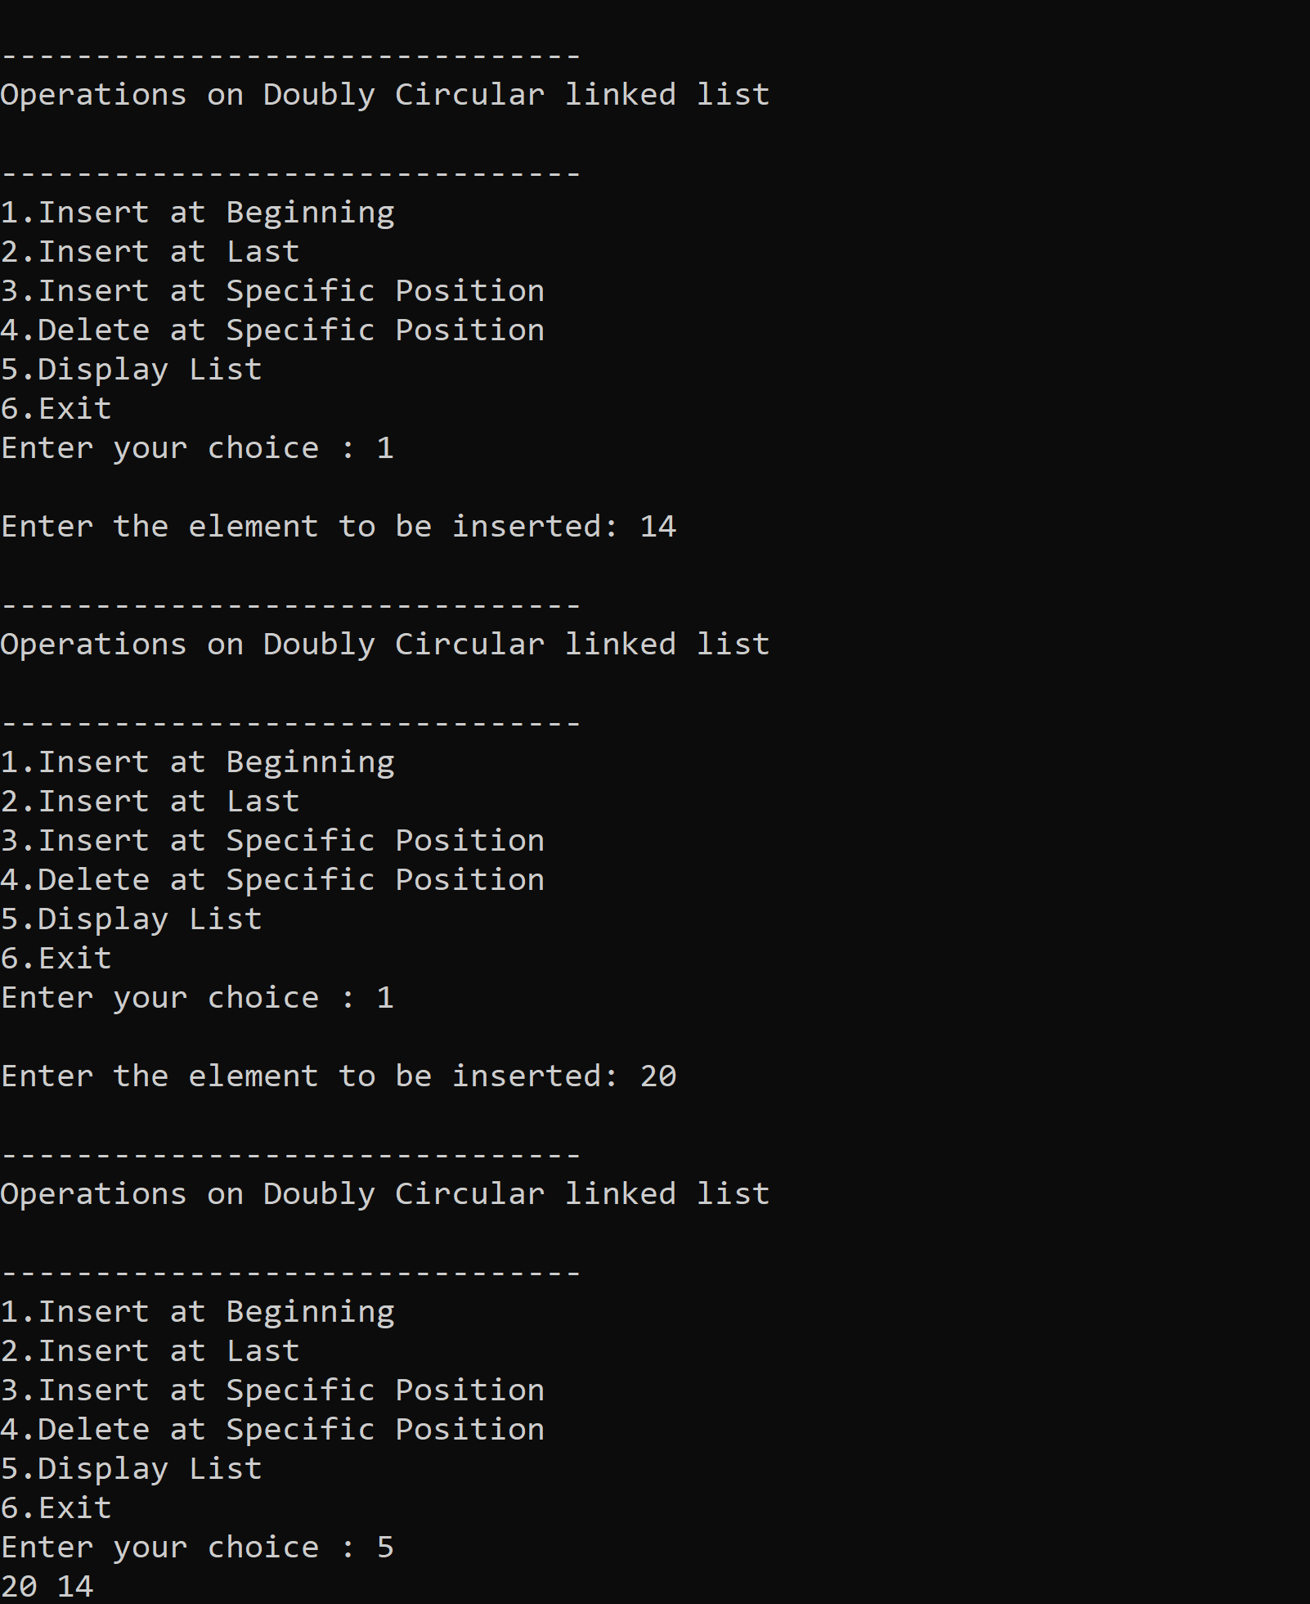
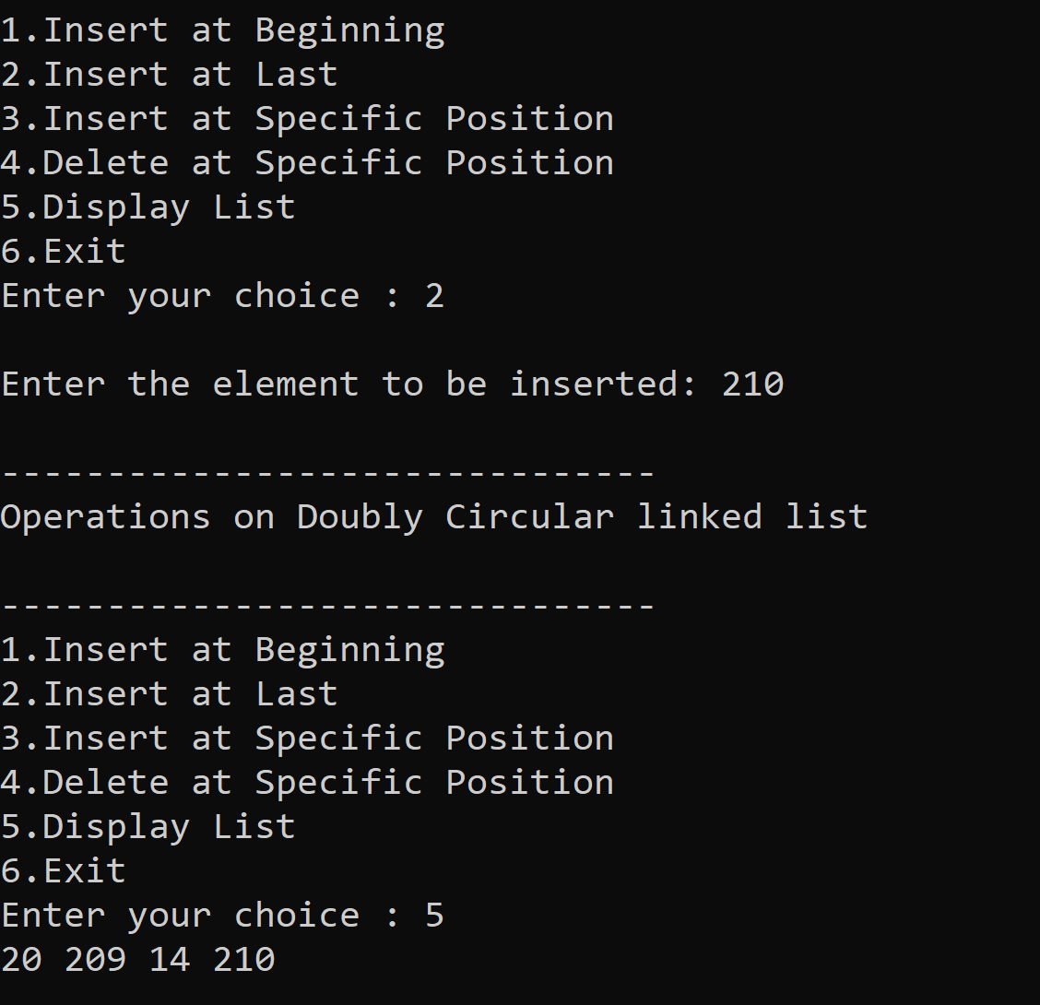
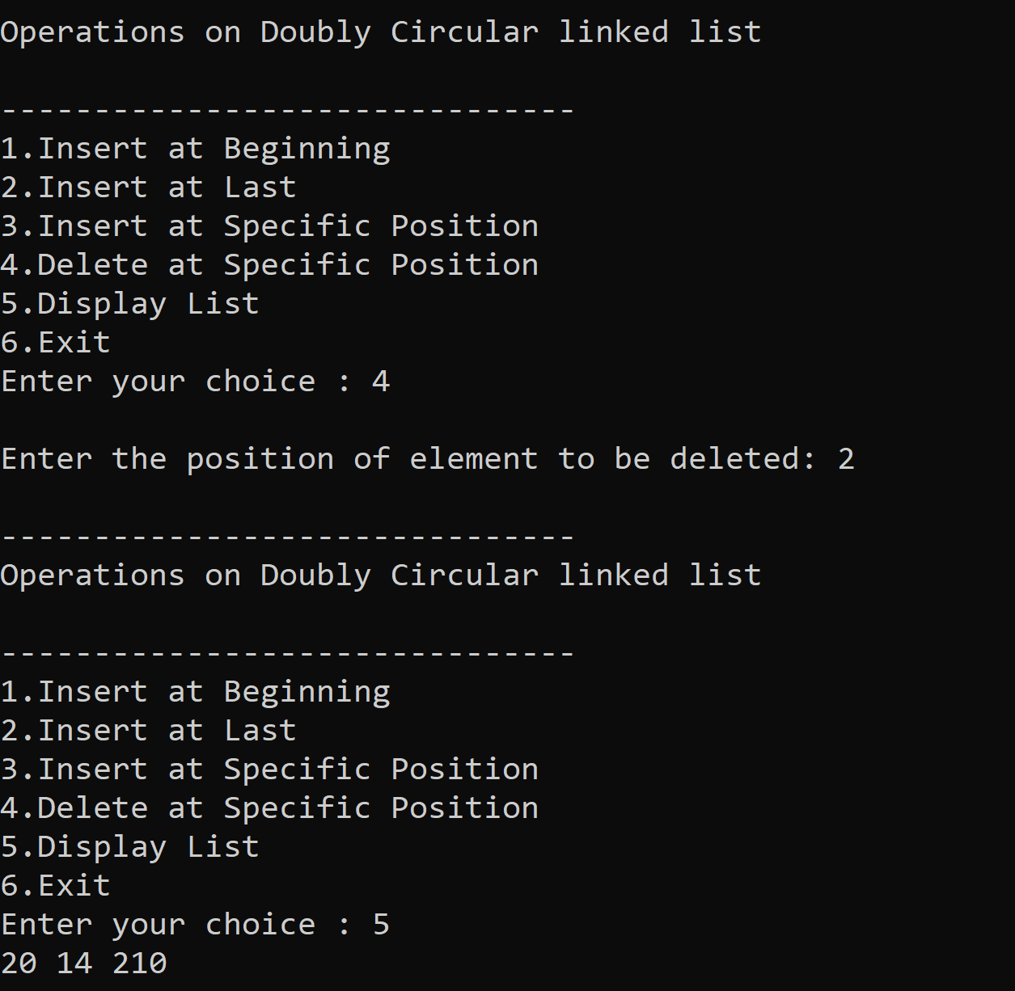
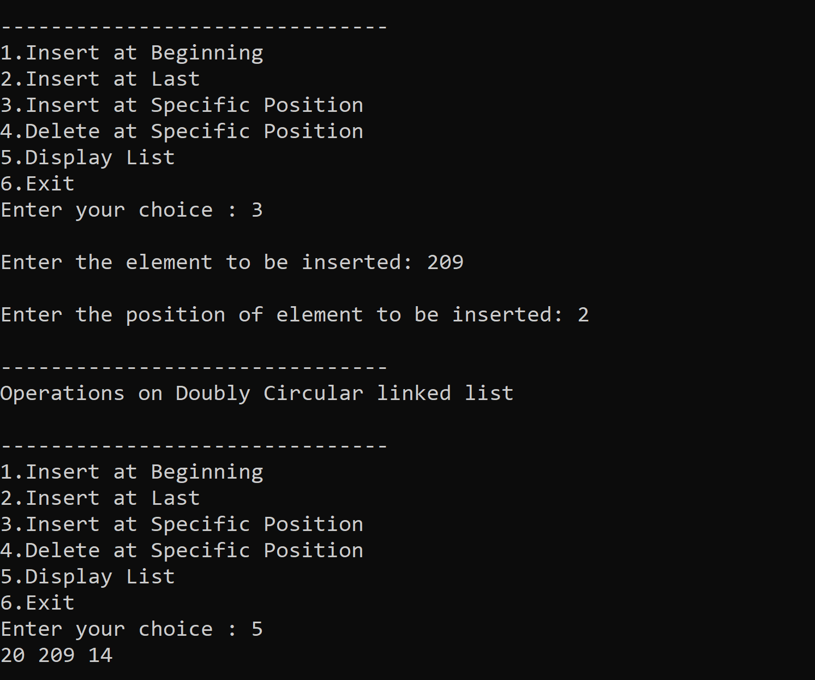

CS250: Data Structures and Algorithms Page 6

National University of Sciences & Technology (NUST) Balochistan Campus (NBC), Department of Computer Science
Deliverables
Compile a single word document by filling in the solution part and submit this Word file on LMS. This lab grading policy is as follows: The lab is graded between 0 to 10 marks. The submitted solution can get a maximum of 5 to 10 marks. At the end of each lab or in the next lab, there will be a viva related to the tasks. The viva has a weightage of 5 marks. Insert the solution/answer in this document. You must show the implementation of the tasks in the designing tool, along with your complete Word document to get your work graded. You must also submit this Word document on the LMS/ Google class room. In case of any problems with submissions on LMS / Google Class room , submit your Lab assignments by emailing it to Mr. Safder Ali students.em96@gmail.com .
CS250: Data Structures and Algorithms Page 7

